VIDEOVIGILANCIA

Miguel Ángel Cuadros Alfonso

[macuadrosa@libertadores.edu.co](mailto:macuadrosa@libertadores.edu.co)

I Introduction  
  
This project is based on security cameras, but with the difference that the videos will be saved on a private server you can save it on the camera itself and improve the detection of unwanted people  
The basis of all this is through the micro controller called esp32 connected via wifi connection the idea is that it is the smallest and improve the quality of recording in the small cameras and that all the recordings are saved on a private server  
Because it's important   
Disassembly: The presence of security cameras acts as a powerful deterrent for criminals.  
Evidence: Video recordings serve as evidence in case of incidents, facilitating the identification of suspects and the resolution of cases.  
Real-time monitoring: Enables quick response to emergencies or suspicious events.  
Various applications: It is used in a wide variety of environments, from homes and to entire cities.  
  
II Summary  
  
This project seeks to revolutionize video surveillance by offering a more secure, efficient and customizable system. Combining the power of the ESP32 microcontroller with cloud storage capability opens up a range of possibilities for both domestic and commercial

No es IEEE

applications  
  
III Explanation of its functioning  
  
The esp32 with camera connected to a rechargeable battery together with a motion sensor if the sensor detects motion this will turn on the camera to be able to take a picture and send to the cloud along with a notification to warn that there is something that has moved in the set perimeter and the recordings will be recorded in a memory to protect and verify is recorded as soon as the sensor detects a movement and when it stops detecting it automatically shuts this out in order to save battery and that lasts longer than 15 minutes lasts between mind approximately 24 hours

IV network diagram  
  
  
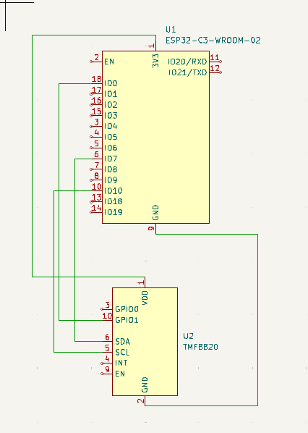

V Node Diagram  
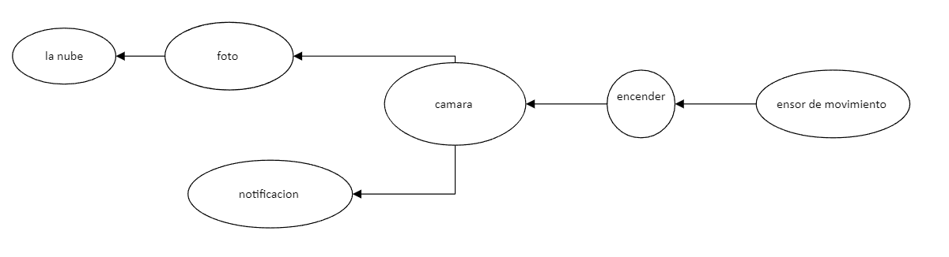  
  
  
  
  
VI Methodological framework  
  
• Target definition  
  
set up esp32 with camera to be able to notify home security via wifi for home security and keep home safe  
  
• Analysis of the environment  
  
It should be visualized and verified that there is no obstruction in the sensor part as this is the one that notifies if a person enters the perimeter or in a detection area for the sensor  
  
• Infrastructure design  
  
The location of the device is versatile as it is yours where to put it and place it if you want to leave it in a window, door or balcony, that is your choice  
  
  
  
• Configuration  
  
To adjust the sensor to the extent you are assigned or you want to change that factor, you will have to change the programming of the sensor so that it fits your home or the need that may be needed  
  
  
• Evidence  
  
One of the tests is that of the sensor as this if it is not configured properly would end up discharging the battery or could fail in recording or in the worst case would never record and would not take the photo  
  
• Implementation  
Physical installation of cameras and equipment.  
Configuration of devices and software.  
System tests and adjustments.  
• Additional considerations   
  
The microphone will not be deployed in the camera due to light subjects   
  
In the long term it is planned to implement with other security measures such as alarms and access control

VII References

[1] <https://instalacionestrue.com/>

[2] <https://www.segurilatam.com/>

[3] <https://argos.red/>

[4] <https://grekkom.com/>

[5] <https://bsai.com.mx/>

[6] Laner-america.com

[7] <https://www.redatel.net/>

[8] <https://www.tecnoseguro.com/>